

Planning Documentation

FIT3175 - Assignment 1

Nimaya Kodikara- 26952467

5pm Fri 24/08/18

Table of Contents

Project Analysis 3

Client 3

Overview of project requirements 3

Client’s target demographic 3

Visual Design Research 4

Information Architecture 9

Desktop wireframe diagram 10

Mobile wireframe diagram 11

References 12

# Project Analysis

This report will document the research and planning process that I have undergone in preparation for building a web page prototype for the Human Rights Arts & Film Festival’s (HRAFF) 2019 website launch. For the first assignment, I have chosen to design a prototype for the home page of the website because that is usually the first page the user navigates to and it is a good page to base your design off of because it includes features from across the site.

## Client

The client, HRAFF, is a not-for-profit arts organisation that provides a platform for artists, organisations and the Australian public to share their stories through film, art, music and other various mediums. They are approaching their 12th year of establishment and will be touring nationally in 2019 from May to June.

They have approached Monash University students to create potential site designs and proof-of-concept prototypes for its upcoming website redesign, launching in April 2019.

## Overview of project requirements

Here is an overview of the client’s requirements for their website:

* Professional web page design
* A site that is engaging to the target demographic
* Inclusion of clear sponsor branding and logo placements on the web page
* Content that is easily managed by the blogging platform, Wordpress
* Inclusion of standard pages, news posts, information architecture, festival events, event venues and advertisements that can all be managed by Wordpress
* Optimised, responsive design for desktop and mobile web browsers
* Universal accessibility and usability for all user types

## Client’s target demographic

The target demographic would consist of art and film lovers, people interested in human rights, potential donors and volunteers and current and future sponsors.

Here is an example of user persona who is a sponsor of the HRAFF site:

|  |  |
| --- | --- |
| **Persona:** | Donor for HRAFF for 11 years |
| **Fictional name:** | Melanie Raffertson |
| **Job title/major responsibilities:** | CEO of an organic cosmetic company |
| **Demographic:** | * 51-year-old, female * Married with 3 kids * Lover of art, film and advocate of human rights |
| **Goals and Tasks:** | * Passionate about creating organic ethical products for all kinds of people * Passionate about keeping HRAFF alive so that human stories are continually being shared |
| **Environment:** | Competent in navigating the internet, as she uses it in her everyday work-life. Uses a mobile phone more than her desktop and has high-speed internet connection. |
| **Quote:** | “How can we make this better for everyone?” |

Here is an example of potential user persona who would like to buy tickets to a film from HRAFF:

|  |  |
| --- | --- |
| **Persona:** | Potential buyer of tickets to a film |
| **Fictional name:** | Kevin Peterson |
| **Job title/major responsibilities:** | University student, volunteers at an opportunity shop in his spare time |
| **Demographic:** | * 21-year-old, male * University student, studying Arts * Lover of films and human stories |
| **Goals and Tasks:** | * Buy tickets to view a specific film from the festival in 2019 |
| **Environment:** | Very competent with using computers, uses Google Chrome on an everyday basis. Uses both mobile and desktop platforms equally. Does not always have access to high-speed internet. |
| **Quote:** | “Where and how can I buy tickets to see this film?” |

# Visual Design Research

1. **Fixed, top navigation bar**

Sydney Film Festival home page <https://www.sff.org.au/>

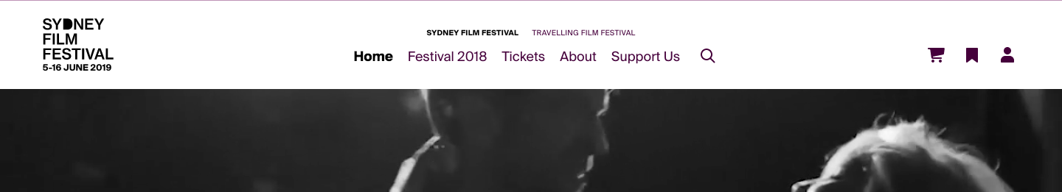

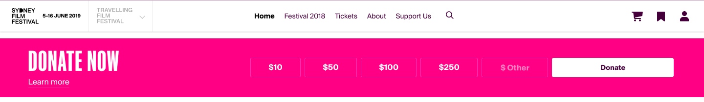

* When you scroll down the page the navigation bar stays present at the top of the screen and there is a ‘collapsing’ animation
* I like how the navigation bar is always visible at the top as it is easy for the user to access those pages

1. **Carousel of images**

Melbourne International Film Festival home page <http://miff.com.au/>

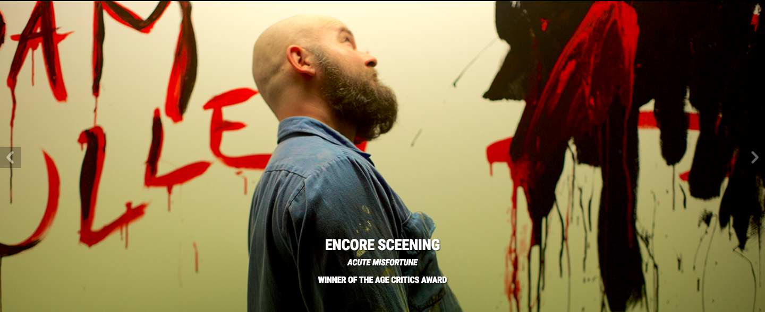

* A carousel where you can click through images or have the images automatically change through the slide show
* I like this idea because, film festivals would have evocative film posters and/or scenes that can be used to capture the user’s attention when they visit the home page

1. **Auto-playing video of clips**

Sydney Film Festival home page <https://www.sff.org.au/>

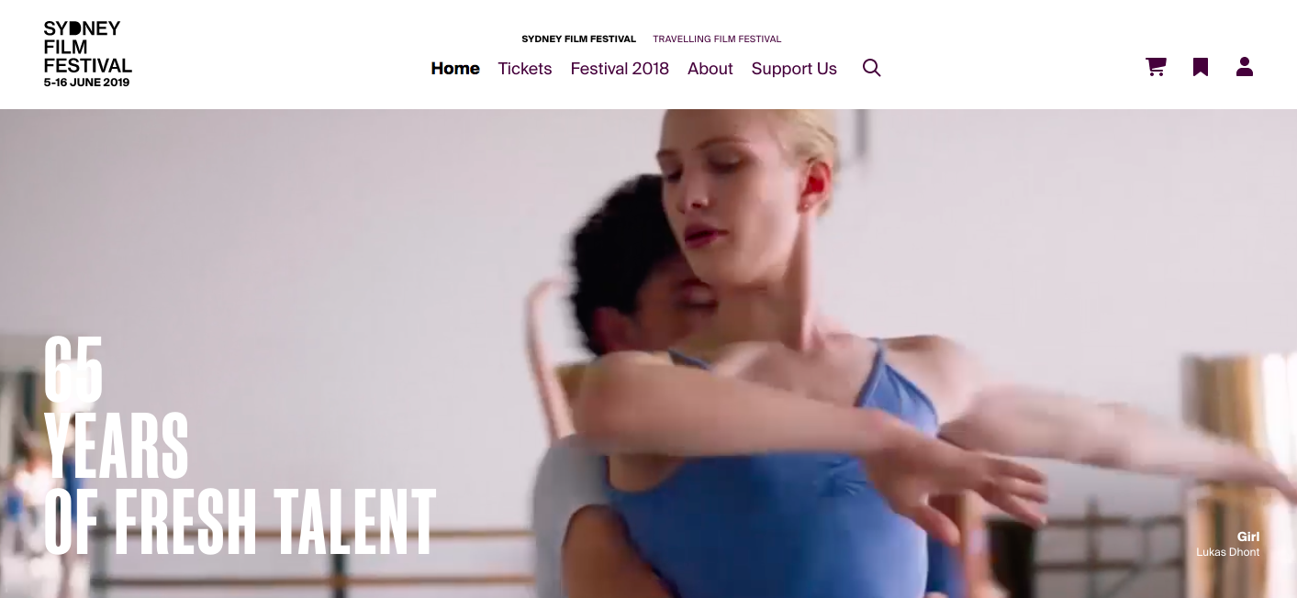

Byron Bay Film Festival home page <https://www.bbff.com.au/>

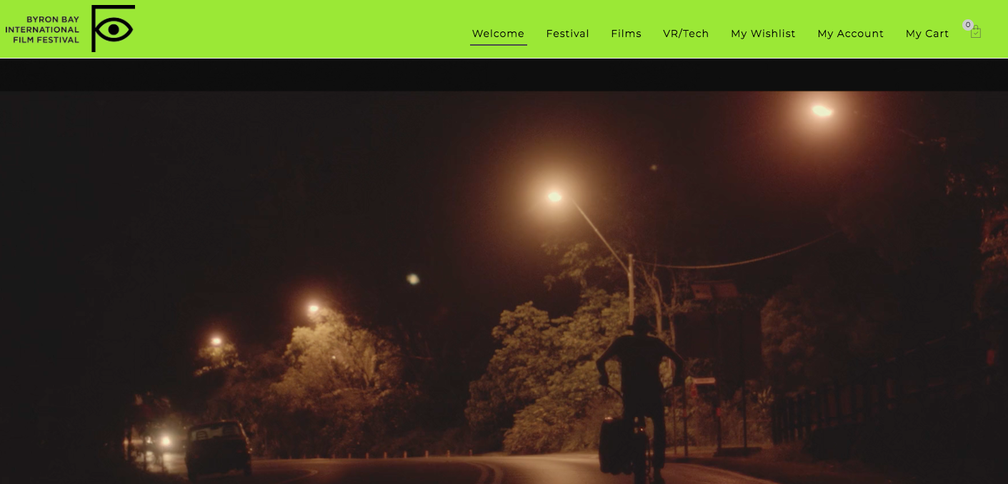

* A section for a video of clips, below the navigation bar that automatically plays when you first visit the site
* I think this is a modern website design element and gives the user a feel for what types of films will be played at the festival

1. **Catalogue of films presented as a carousel**

Melbourne International Film Festival home page <http://miff.com.au/>

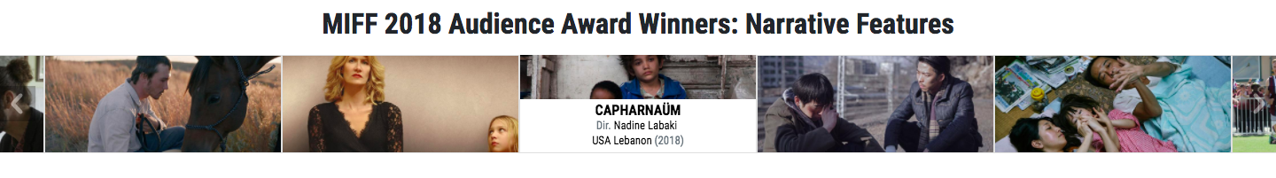

* A catalogue of films that one can click through
* I think this is a modern website design element and gives the user a feel for what types of films will be played at the festival

1. **News articles displayed as cards**

Melbourne International Film Festival home page <http://miff.com.au/>

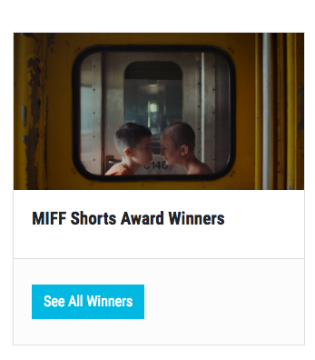

* News cards where users can click on to learn more
* I like the simplistic design of this element

1. **Footer with social media links**

Byron Bay Film Festival home page <https://www.bbff.com.au/>

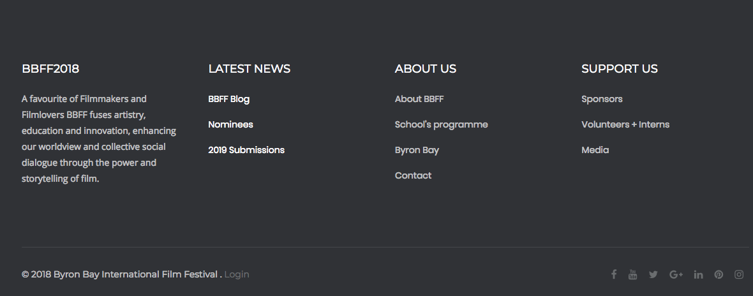

* The larger footer is eye-catching and very easy for the user to navigate to what they want quickly

1. **Sections with fixed backgrounds**

Vision Splendid Film Festival  http://www.visionsplendidfilmfest.com/

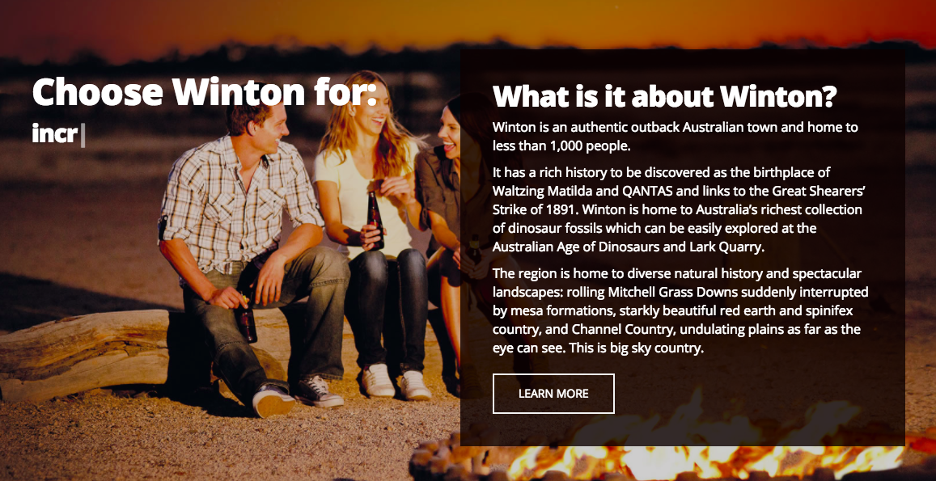

* The fixed background is very aesthetically pleasing and achieves a nice effect when scrolling down the page

1. **‘Buy tickets fast’ section**

Village cinemas homepage <https://villagecinemas.com.au/>

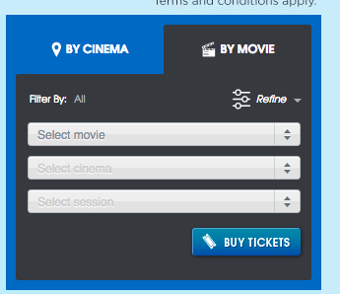

* The ‘buy tickets fast’ section is very convenient for a user who is in a hurry to buy tickets

1. **Distinct ‘donate now’ button**

Oxfam homepage <https://www.oxfam.org.au/>

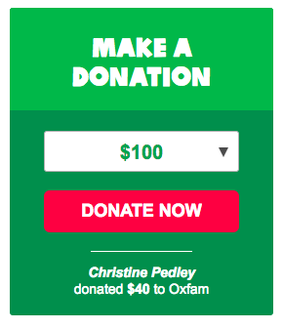



* The ‘donate now’ sections on the website are eye-catching and will alert the user that they can donate now

1. **Hamburger menu and navigation bar on mobile devices**

Sydney Film Festival home page <https://www.sff.org.au/>

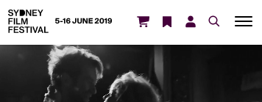

* The hamburger menus in the mobile devices are very convenient for the user who uses mobile devices to navigate to different pages

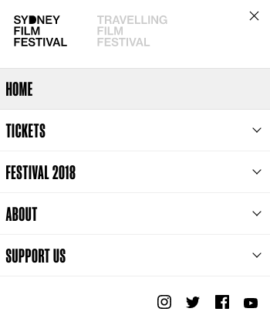

# Information Architecture

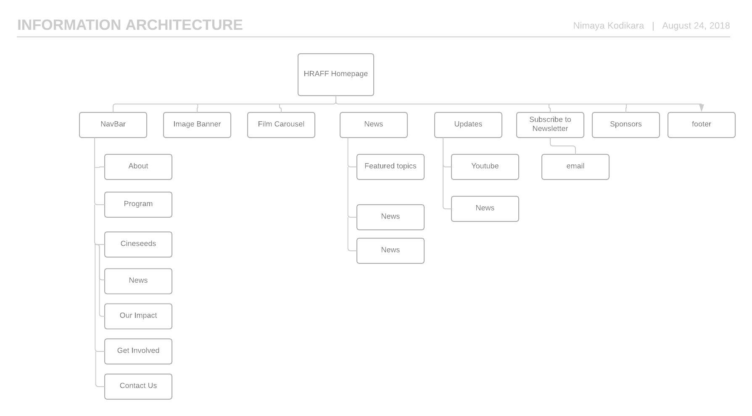

# Desktop wireframe diagram

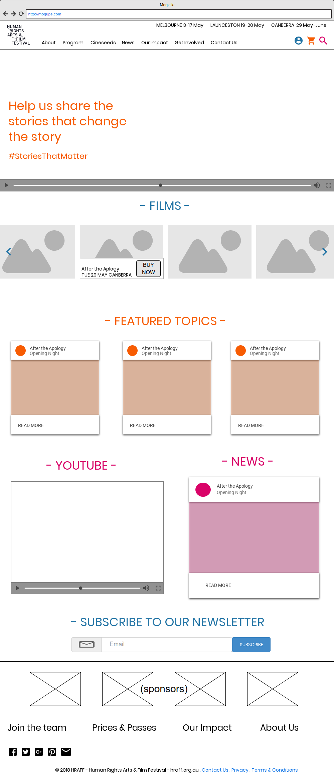

# Mobile wireframe diagram

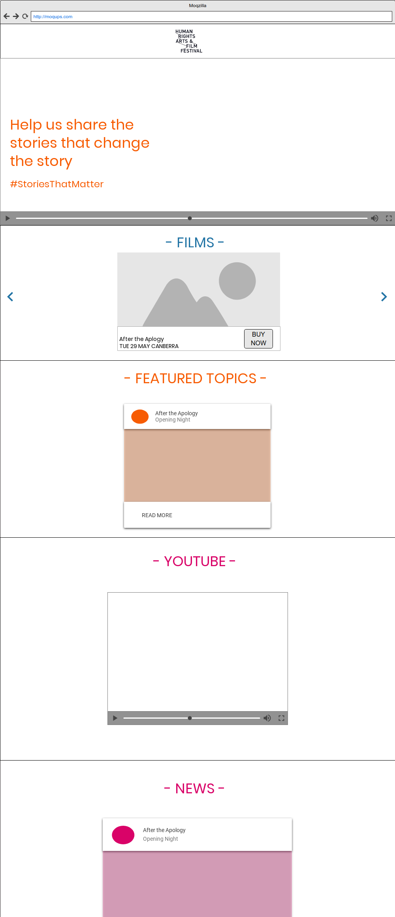

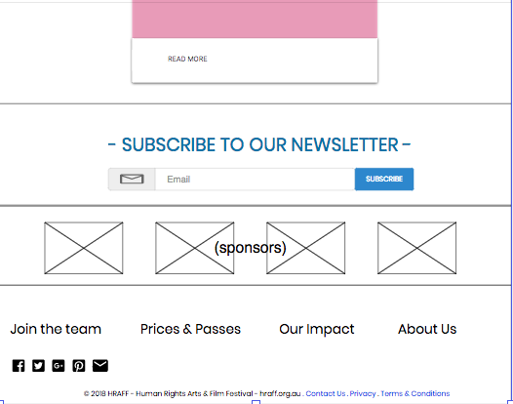

References

* Melbourne International Film Festival home page <http://miff.com.au/>
* Sydney Film Festival home page <https://www.sff.org.au/>
* Byron Bay Film Festival home page <https://www.bbff.com.au/>
* Vision Splendid Film Festival  http://www.visionsplendidfilmfest.com/
* Oxfam homepage <https://www.oxfam.org.au/>
* Village cinemas <https://villagecinemas.com.au/>
* Images appearing on prototype: <https://www.pexels.com/search/people/>
* Youtube video: <https://www.youtube.com/watch?v=jjzLrIdTWmc/>